AMPHIBIANS
Lesson no 34
General Characteristics of Amphibians
- Amphibians are cold blooded vertebrates which can hue on land and in water.
- Amphibians show four limbs with which they can swim in water and jump or walk on the land, (But in apoda limbs are absent.)
- In Amphibians animals exoskeleton is absent. But in apoda animals small cycloid scales are present.
- In Amphibians the adult animals lungs are present. Gills are absent. But In some urodelans the gills are present.
- Amphibians Skin is a respiratory organ.
- The Amphibians skull is dicondylic.
- Amphibians Ribs are absent.
- In Amphibians The body divisible into head and trunk Tail is present in, urodela animals.
- Amphibians Digestive system is well developed. A well developed liver Is present
- External ear is absent. Middle and inner ears are present, the middle ear columella auris Is present.
- Amphibians Heart is 3 chambered with 2 auricles and 1 ventricle The blood contains R.B.C. They are nucleated. They contain hemoglobin.
- Blood vascular system contain hepatic and renal portal systems.
- Amphibians Kidneys are mesonephric. Urinary bladder is present. It stores urine.
- Central nervous system is well developed. The brain occupies completely the cranial cavity. The brain is divided into fore, mid and hind brains. Brain continuous as spinal cord.
15. 10 pairs of cranial nerves will arise.
- Sexes are separate.
- Male and female can be indentified - Sexual dimorphism.
- In Amphibians the life history a larva stage may be present.
- Amphibian Eggs are telolecithal, Cleavage is holoblastic unequal.

Lesson no 35

Phylogenetic relationships
During the ﬁrst 250 million years of vertebrate history, adaptive radiation resulted in vertebrates ﬁlling most aquatic habitats. Prehistoric waters contained many active, powerful predators. Land, however, was free of vertebrates and, except for some arthropods, was free of predators. Animals that moved around the water’s edge were not likely to be prey for other animals. With lungs for breathing air and muscular ﬁns for scurrying across mud, these animals probably found ample food in the arthropods that lived there. The major component of the diet of most modern amphibians is arthropods.
Adaptive radiation of amphibians resulted in a much greater variety of forms than exists today. Later convergent and parallel evolution and widespread extinction clouded evolutionary pathways. No one knows, therefore, what animal was the ﬁrst amphibian, but the structure of limbs, skulls, and teeth suggests that Ichthyostega is probably similar to the earliest amphibians (figure 19.2). Two lineages of early amphibians from the late Devonian and early Carboniferous periods can be distinguished by how the roof and the posterior portion of the skull attach to each other. One lineage of amphibians became extinct late in the Carboniferous period. An amniotic egg that resisted drying evolved in this group. This lineage, called the amniote lineage, left as its descendants the reptiles, birds, and mammals (ﬁgure 19.3). A second lineage flourished into the Jurassic period. Most of this lineage became extinct, but not before giving rise to the three orders of living amphibians. This lineage is called the nonamniote lineage.

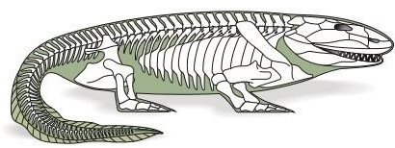
Ichthyostega: An Early Amphibian. Fossils of this early amphibian were discovered in eastern Greenland in late Devonian deposits. The total length of the restored specimen is about 65 cm. Terrestrial adaptations are heavy pectoral and pelvic girdles and sturdy limbs that probably helped lift the body off the ground. Strong jaws suggest that it was a predator in shallow water, perhaps venturing onto shore. Other features include a skull that is similar in structure to ancient sarcopterygian ﬁshes and a ﬁnlike tail. Note that bony rays dorsal to the spines of the vertebrae support the tail ﬁn. This pattern is similar to the structure of the dorsal ﬁns of ﬁshes and is unknown in any other tetrapod
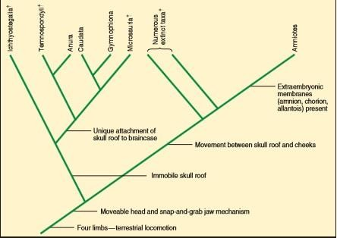
Evolutionary Relationships among the Amphibians. Earliest amphibians arose during the Devonian period. A nonamniotic lineage gave rise to three classes of modern amphibians and numerous extinct taxa. Some zoologists think that the class Amphibia is a paraphyletic group. If this is true, the three modern classes should be represented as monophyletic taxa. The amniotic lineage of early tetrapods gave rise to reptiles, birds, mammals, and other extinct taxa. Daggers (†) indicate extinct taxa. Synapomorphic characters for lower taxonomic groups are not indicated.

Lesson no 36
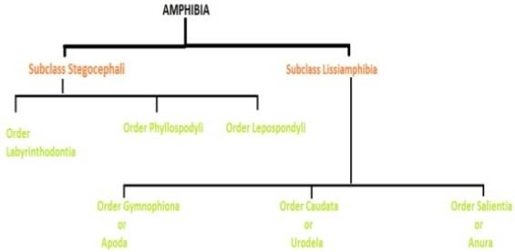
Classification of Amphibians

Sub class Stegocephali
They are extinct species, Pendatactyl limbs and skin with scales and bony plates

Order Labyrinthodontia
They are primitive amphibians, also known as “Stem Amphibia”. Their teeth large with folded dentine same as crossoptergian (fishes) E.g. Eryops (Extinct).

Order Phyllospondyli
They are small Salamander like, notochord and spinal cord housed in common cavity E.g, Branchiosaurs.

Order Lepospondyli
They are Small eel like vertebrea of single piece. Neural arch and centrum is continuous. For Example Diplocaulus (Extint).

Subclass Lissiamphibia
These are modern Amphibia. No scales are present. Teeth are small and simple

Order Apoda
This order is also known as Gymnophiona. No limbs or limb girdles are present. These are Blind. Wormlike, legless amphibians with indistinct or even hidden eyes. They have a series of annular grooves (annuli) are usually present along the length of the body, heightening the resemblance to an earthworm. Most caecilians lead a burrowing existence, although members of one genus, Typhlonectes, are aquatic.
Some species have the eyes hidden beneath the bones of the skull and probably are blind, but others at least are able to distinguish movement. A series of annular grooves (annuli) are usually present along the length of the body, heightening the resemblance to an earthworm. Most caecilians lead a burrowing existence, although members of one genus, Typhlonectes, are aquatic. Some species have the eyes hidden beneath the bones of the skull and probably are blind, but others at least are able to distinguish movement. At larval stages they have teeth, are carnivores and have limbs during most of their development. Further subdivided into five suborders. Cryptobranchoidea, Salamandriodea, Ambystomatoidea, Proteidea, Meantes. E.g. Ambystoma, Siren
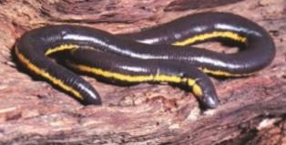
Order Gymnophiona. A caecilian (Ichthyophis glutinosus).

Order caudata
Members of the order Caudata (kawdat-ah) (L. cauda, tail Gr. ata, to bear) are the salamanders. They possess a tail throughout life, and both pairs of legs, when present, are relatively unspecialized (ﬁgure 19.4). Approximately 115 of the 350 described species of salamanders live in North America. Most terrestrial salamanders live in moist forest-ﬂoor litter and have aquatic
larvae. A number of families live in caves, where constant temperature and moisture conditions create a nearly ideal environment. Salamanders in the family Plethodontidae are the most fully terrestrial salamanders in that their eggs are laid on land, and the young hatch as miniatures of the adult. Members of the family Salamandridae are commonly called newts. They spend most of their lives in water and frequently retain caudal ﬁns. Salamanders range in length from only a few centimeters to 1.5 m (the Japanese giant salamander, Andrias japonicus). The largest North American salamander is the hellbender (Cryptobranchus alleganiensis), which reaches lengths of about 65 cm. Most salamanders have internal fertilization. Males produce a pyramidal, gelatinous spermatophore that is capped with sperm and deposited on the substrate. Females pick up the sperm cap with the cloaca and store the sperm in a special pouch, the spermatheca. Eggs are fertilized as they pass through the cloaca and are usually deposited singly, in clumps, or in strings (ﬁgure 19.5a). Larvae are similar to adults but smaller. They often possess external gills, a tail ﬁn, larval dentition, and a rudimentary tongue (ﬁgure 19.5b). The aquatic larval stage usually metamorphoses into a terrestrial adult (ﬁgure 19.5c). Many other salamanders undergo incomplete metamorphosis and are paedomorphic (e.g., Necturus); that is, they become sexually mature while still showing larval characteristics.
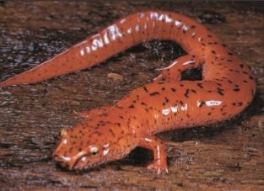
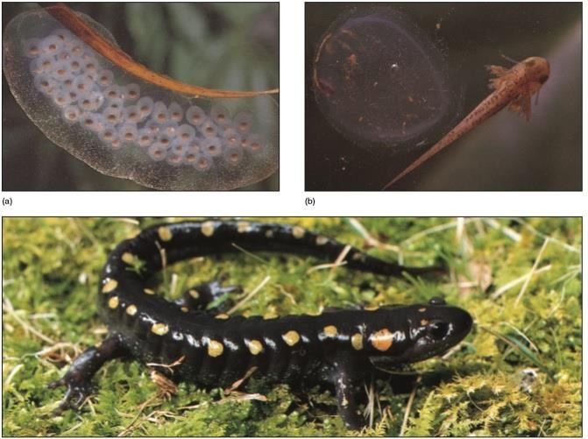
Order Caudata. The Blue Ridge Spring salamander (Gyrinophilus danielsi)

Order Caudata. (a) Eggs, (b) larva, and (c) adult of the spotted salamander, Ambystoma maculatum. Larvae are herbivores, and adults feed on worms and small arthropods.

Order Anura (Salientia)
Tail is absent in adult. Eyelids and tympanum present. Skin scaleless and loose. Further divided into five suborders; Amphicoela, Opisthocoela, Procoela, Diplasiocela. Examples are Frog and Toad. They have Shortened vertebral column (nine or fewer presacral vertebrae). Presence of a urostyle formed from developing tail vertebrae. Absence of tail in adults. Hind limb longer than forelimb.
Fusion of radius and ulna into a single element. Fusion of tibia and fibula into a single element.

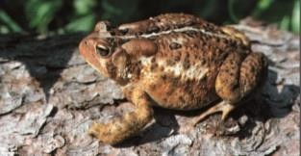
Order Anura. An American toad (Bufo americanus).

Lesson no 37

External structure and locomotion
Vertebrate skin protects against infective microorganisms, ultraviolet light, desiccation, and mechanical injury. As discussed later in this chapter, the skin of amphibians also functions in gas exchange, temperature regulation, and absorption and storage of water. Amphibian skin lacks a covering of scales, feathers, or hair. It is, however, highly glandular, and its secretions aid in protection. These glands keep the skin moist to prevent drying. They also produce sticky secretions that help a male cling to a female during mating and produce toxic chemicals that discourage potential predators. The skin of many amphibians is smooth, although epidermal thickenings may produce warts, claws, or sandpapery textures, which are usually the result of keratin deposits or the formation of hard, bony areas. Chromatophores are specialized cells in the epidermis and dermis of the skin that are responsible for skin color and color changes. Cryptic coloration, aposematic coloration, and mimicry are all common in amphibians.
Support and Movement Water buoys and supports aquatic animals. The skeletons of ﬁshes function primarily in protecting internal organs, providing points of attachment for muscles, and keeping the body from collapsing during movement. In terrestrial vertebrates, however, the skeleton is modiﬁed to provide support against gravity, and it must be strong enough to support the relatively powerful muscles that propel terrestrial vertebrates across land. The amphibian skull is ﬂattened, is relatively smaller, and has fewer bony elements than the skull of ﬁshes. These changes lighten the skull so it can be supported out of the water. Changes in jaw structure and musculature allow terrestrial vertebrates to crush prey held in the mouth. The vertebral column of amphibians is modiﬁed to provide support and ﬂexibility on land (ﬁgure 19.8). It acts somewhat like the arch of a suspension bridge by supporting the weight of the body between anterior and posterior paired appendages. Supportive processes called zygapophyses on each vertebra prevent twisting. Unlike ﬁshes, amphibians have a neck. The ﬁrst vertebra is a cervical vertebra, which moves against the back of the skull and allows the head to nod vertically. The last trunk vertebra is a sacral vertebra. This vertebra anchors the pelvic girdle to the vertebral column to provide increased support. A ventral plate of bone, called the sternum, is present in the anterior ventral trunk region and supports the forelimbs and protects internal organs. It is reduced or absent in the Anura. The origin of the bones of vertebrate appendages is not precisely known; however, similarities in the structures of the bones of the amphibian appendages and the bones of the ﬁns of ancient sarcopterygian ﬁshes suggest possible homologies (ﬁgure 19.9). Joints at the shoulder, hip, elbow, knee, wrist, and ankle allow freedom of movement and better contact with the substrate. The pelvic girdle of amphibians consists of three bones (the ilium, ischium, and pubis) that firmly attach pelvic appendages to the vertebral column. These bones, which are present in all tetrapods, but not ﬁshes, are important for support on land.

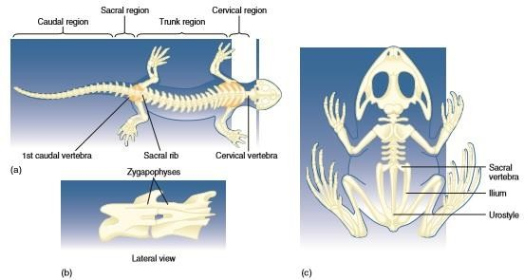

Skeletons of Amphibians. (a) The salamander skeleton is divided into four regions: cervical, trunk, sacral, and caudal. (b) Interlocking processes, called zygapophyses, prevent twisting between vertebrae. (c) A frog skeleton shows adaptations for jumping. Note the long back legs and the ﬁrm attachment of the back legs to the vertebral column through the ilium and urostyle.
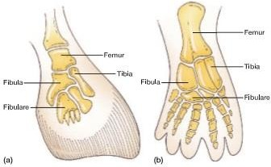
Origin of Tetrapod Appendages. A comparison of (a) the ﬁn bones of a rhipidistian and (b) the limb bones of a tetrapod suggests that the basic bone arrangements in tetrapod limbs were already present in primitive ﬁshes.

Tetrapods depend more on appendages than the body wall for locomotion. Thus, body-wall musculature is reduced, and appendicular musculature predominates. (Contrast, for example, what you eat in a ﬁsh dinner as compared to a plate of frog legs.) Salamanders employ a relatively unspecialized form of locomotion that is reminiscent of the undulatory waves that pass along the body of a ﬁsh. Terrestrial salamanders also move by a pattern of limb and body movements in which the alternate movement of appendages results from muscle contractions that throw the body into a curve to advance the stride of a limb (ﬁgure 19.10). Caecilians have an accordion-like movement in which adjacent body parts push or pull forward at the same time. The long hindlimbs and the pelvic girdle of anurans are modiﬁed for jumping. The dorsal bone of the pelvis (the ilium) extends anteriorly and securely attaches to the vertebral column, and the urostyle extends posteriorly and attaches to the pelvis (see ﬁgure 19.8). These skeletal modiﬁcations stiffen the posterior half of the anuran. Long hindlimbs and powerful muscles form an efﬁcient lever system for jumping. Elastic connective tissues and muscles attach the pectoral girdle to the skull and vertebral column, and function as shock absorbers for landing on the forelimbs.

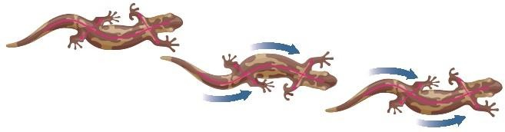
Salamander Locomotion. Pattern of leg movement in salamander locomotion. Blue arrows show leg movements.

Lesson no 38
NUTRITION AND THE DIGESTIVE SYSTEM
Most adult amphibians are carnivores that feed on a wide variety of invertebrates. The diets of some anurans, however, are more diverse. For example, a bullfrog will prey on small mammals, birds, and other anurans. The main factors that determine what amphibians will eat are prey size and availability. Most larvae are herbivorous and feed on algae and other plant matter. Most
amphibians locate their prey by sight and simply wait for prey to pass by. Olfaction plays an important role in prey detection by aquatic salamanders and caecilians. Many salamanders are relatively unspecialized in their feeding methods, using only their jaws to capture prey. Anurans and plethodontid salamanders, however, use their tongue and jaws in a ﬂip-and-grab feeding mechanism (ﬁgure 19.11). A true tongue is ﬁrst seen in amphibians. (The “tongue” of ﬁshes is simply a ﬂeshy fold on the ﬂoor of the mouth. Fish food is swallowed whole and not manipulated by the “tongue”.) The amphibian tongue attaches at the anterior margin of the jaw and folds back over the ﬂoor of the mouth. Mucous and buccal glands on the tip of the tongue exude sticky secretions. When prey comes within range, an amphibian lunges forward and ﬂicks out its tongue. The tongue turns over, and the lower jaw is depressed. The head tilts on its single cervical vertebra, which helps aim the strike. The tip of the tongue entraps the prey, and the tongue and prey are ﬂicked back inside the mouth. All of this may happen in 0.05 to 0.15 second! The amphibian holds the prey by pressing it against teeth on the roof of the mouth, and the tongue and other muscles of the mouth push food toward the esophagus. The eyes sink downward during swallowing and help force food toward the esophagus.

Lesson no 39
CIRCULATION, GAS EXCHANGE, AND TEMPERATURE REGULATION
The circulatory system of amphibians shows remarkable adaptations for a life divided between aquatic and terrestrial habitats. The separation of pulmonary and systemic circuits is less efﬁcient in amphibians than in lungﬁshes (ﬁgure 19.12; see also ﬁgure 18.15b). The atrium is partially divided in urodeles and completely divided in anurans. The ventricle has no septum. A spiral valve in the conus arteriosus or ventral aorta helps direct blood into pulmonary and systemic circuits. As discussed later, gas exchange occurs across the skin of amphibians, as well as in the lungs. Therefore, blood entering the right side of the heart is nearly as well oxygenated as blood entering the heart from the lungs! When an amphibian is completely submerged, all gas exchange occurs across the skin and other moist surfaces; therefore, blood coming into the right atrium has a higher oxygen concentration than blood returning to the left atrium from the lungs.

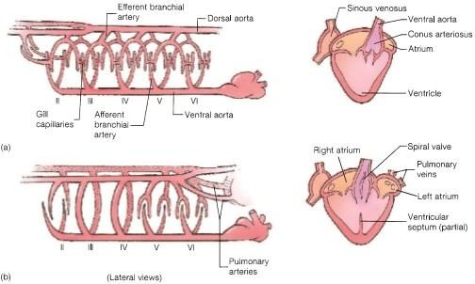

Circulatory System of Fishes. Diagrammatic representation of the circulatory systems of (a) bony ﬁshes and (b) lungﬁshes. Hearts are drawn from a ventral view. Major branches of arteries carrying blood to and from the gills are called branchial arteries (or embryologically, aortic arches) and are numbered with Roman numerals. They begin with II because aortic arch I is lost during embryological development.
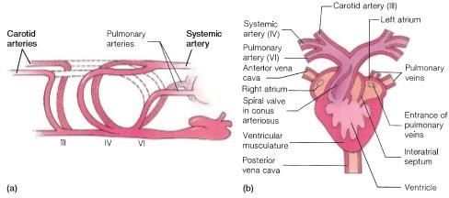

Diagrammatic Representation of an Anuran Circulatory System. (a) The Roman numerals indicate the various aortic arches. Vessels shown in dashed outline are lost during embryological development. (b) A ventral view of the heart.

Under these circumstances, blood vessels leading to the lungs constrict, reducing blood ﬂow to the lungs and conserving energy. This adaptation is especially valuable for those frogs and salamanders that overwinter in the mud at the bottom of a pond. Adult amphibians have fewer aortic arches than ﬁshes. After leaving the conus arteriosus, blood may enter the carotid artery (aortic arch III), which takes blood to the head; the systemic artery (aortic arch IV), which takes blood to the body; or the pulmonary artery (aortic arch VI). In addition to a vascular system that circulates blood, amphibians have a well-developed lymphatic system of blindending vessels that returns ﬂuids, proteins, and ions ﬁltered from capillary beds in tissue spaces to the circulatory system. The lymphatic system also transports water absorbed across the skin. Unlike other vertebrates, amphibians have contractile vessels, called lymphatic hearts, that pump ﬂuid through the lymphatic system. Lymphatic spaces between body-wall muscles and the skin transport and store water absorbed across the skin.

Gas Exchange
Terrestrial animals expend much less energy moving air across gas exchange surfaces than do aquatic organisms because air contains 20 times more oxygen per unit volume than does water. On the other hand, exchanges of oxygen and carbon dioxide require moist surfaces, and exposure of respiratory surfaces to air may result in rapid water loss. Anyone who has searched pond and stream banks for frogs knows that the skin of amphibians is moist. Amphibian skin is also richly supplied with capillary beds. These two factors permit the skin to function as a respiratory organ. Gas exchange across the skin is called cutaneous respiration and can occur either in water or on land. This ability allows a frog to spend the winter in the mud at the bottom of a pond. In salamanders, 30 to 90% of gas exchange occurs across the skin. Gas exchange also occurs across the moist surfaces of the mouth and pharynx. This buccopharyngeal respiration accounts for 1 to 7% of total gas exchange. Most amphibians, except for plethodontid salamanders, possess lungs (ﬁgure 19.13a). The lungs of salamanders are relatively simple sacs. The lungs of anurans are subdivided, increasing the surface area for gas exchange. Pulmonary (lung) ventilation occurs by a buccal pump mechanism. Muscles of the mouth and pharynx create a positive pressure to force air into the lungs (ﬁgure 19.13b–e).

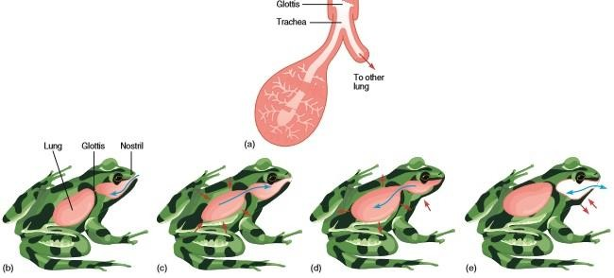

FIGURE 19.13 Amphibian Lung Structure, Buccal Pump, and Buccopharyngeal Ventilation. (a) Lung structure of a frog. (b) With the opening of the respiratory tract (the glottis) closed, the ﬂoor of the mouth lowers, and air enters the mouth cavity. (c) The glottis opens, and the elasticity of the lungs and contraction of the body wall force air out of the lungs, over the top of air just brought into the mouth. (d) The mouth and nares close, and the ﬂoor of the mouth raises, forcing air into the lungs. (e) With the glottis closed, oscillations of the ﬂoor of the mouth exchange air in the mouth cavity to facilitate buccopharyngeal respiration. Blue arrows show air movements. Red arrows show movements of the lungs and body wall.
Cutaneous and buccopharyngeal respiration have a disadvantage in that their contribution to total gas exchange is relatively constant. The quantity of gas exchanged across these surfaces cannot be increased when the metabolic rate increases. Lungs, however, compensate for this shortcoming. As environmental temperature and activity increase, lungs contribute more to total gas exchange. At 5° C, approximately 70% of gas exchange occurs across the skin and mouth lining of a frog. At 25° C, the absolute quantity of oxygen exchanged across external body surfaces does not change significantly, but because pulmonary respiration increases, exchange across skin and mouth surfaces accounts for only about 30% of total oxygen exchange. Amphibian larvae and some adults respire using external gills. Cartilaginous rods that form between embryonic pharyngeal slits support three pairs of gills. During metamorphosis, the gills are usually reabsorbed, pharyngeal slits close, and lungs become functional.

Temperature Regulation
Amphibians are ectothermic. (They depend on external heat sources to maintain body temperature [see chapter 28.]) Any poorly insulated aquatic animal, regardless of how much metabolic heat it produces, loses heat as quickly as it is produced because of powerful heat-absorbing properties of the water. Therefore, when amphibians are in water, they take on the temperature of their environment. On land, however, their body temperatures can differ from that of the environment. Temperature regulation is mainly behavioral. Some cooling results from evaporative heat loss. In addition, many amphibians are nocturnal and remain in cooler burrows or under moist leaf litter during the hottest part of the day. Amphibians may warm themselves by basking in the sun or on warm surfaces. Body temperatures may rise 10° C above the air temperature. Basking after a meal is common, because increased body temperature increases the rate of all metabolic reactions— including digestive functions, growth, and the fat deposition necessary to survive periods of dormancy. Amphibians’ daily and seasonal environmental temperatures often ﬂuctuate widely, and therefore, amphibians have correspondingly wide temperature tolerances. Critical temperature extremes for some salamanders lie between
2 and 27°C, and for some anurans between 3 and 41° C.

Lesson no 40
NERVOUS AND SENSORY FUNCTIONS
The nervous system of amphibians is similar to that of other vertebrates. The brain of adult vertebrates develops from three embryological subdivisions. In amphibians, the forebrain contains
olfactory centers and regions that regulate color change and visceral functions. The midbrain contains a region called the optic tectum that assimilates sensory information and initiates motor responses. The midbrain also processes visual sensory information. The hindbrain functions in motor coordination and in regulating heart rate and the mechanics of respiration. Many amphibian sensory receptors are widely distributed over the skin. Some of these are simply bare nerve endings that respond to heat, cold, and pain. The lateral-line system is similar in structure to that found in ﬁshes, and it is present in all aquatic larvae, aquatic adult salamanders, and some adult anurans. Lateral-line organs are distributed singly or in small groups along the lateral and dorsolateral
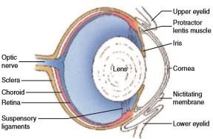
surfaces of the body, especially the head. These receptors respond to low-frequency vibrations in the water and movements of the water relative to the animal. On land, however, lateral-line receptors are less important. Chemoreception is an important sense for many amphibians. Chemoreceptors are in the nasal epithelium and the lining of the mouth, on the tongue, and over the skin. Olfaction is used in mate recognition, as well as in detecting noxious chemicals and in locating food. Vision is one of the most important senses in amphibians because they are primarily sight feeders. (Caecilians are an obvious exception.) A number of adaptations allow the eyes of amphibians to function in terrestrial environments (ﬁgure 19.14). The eyes of some amphibians (i.e., anurans and some salamanders) and well-developed depth perception necessary for capturing prey.
FIGURE 19.14 Amphibian Eye. Longitudinal section of the eye of the leopard frogs.
Other amphibians with smaller lateral eyes (some salamanders) lack binocular vision. The lower eyelid is movable, and cleans and protects the eye. Much of it is transparent and is called the nictitating membrane. When the eyeball retracts into the orbit of the skull, the nictitating membrane is drawn up over the cornea. In addition, orbital glands lubricate and wash the eye. Together, eyelids and glands keep the eye free of dust and other debris. The lens is large and nearly round. It is set back from the cornea, and a fold of epithelium called the iris surrounds it. The iris can dilate or constrict to control the size of the pupil. Focusing, or accommodation, involves
bending (refracting) light rays to a focal point on the retina. Light waves moving from air across the cornea are refracted because of the change in density between the two media. The lens provides further refraction. Like the eyes of most tetrapods, the amphibian eye focuses on distant objects when the eye is at rest. To focus on near objects, the protractor lentis muscle must move the lens forward (ﬁgure 19.14). Receptors called rods and cones are in the retina. Because cones are associated with color vision in some other vertebrates, their occurrence suggests that amphibians can distinguish between some wavelengths of light. The extent to which color vision is developed is unknown. The neuronal interconnections in the retina are complex and allow an amphibian to distinguish between ﬂying insect prey, shadows that may warn of an approaching predator, and background movements, such as blades of grass moving with the wind. The auditory system of amphibians is clearly an evolutionary adaptation to life on land. It transmits both substrateborne vibrations and, in anurans, airborne vibrations. The ears of anurans consist of a tympanic membrane, a middle ear, and an inner ear. The tympanic membrane is a piece of integument stretched over a cartilaginous ring that receives airborne vibrations and transmits them to the middle ear, which is a chamber beneath the tympanic membrane. Abutting the tympanic membrane is a middle-ear ossicle (bone) called the stapes (columella), which transmits vibrations of the tympanic membrane into the inner ear (see ﬁgure 24.20). High-frequency (1,000 to 5,000 Hz) airborne vibrations are transmitted to the inner ear through the tympanic membrane. Low- frequency (100 to 1,000 Hz) substrateborne vibrations are transmitted through the front appendages and the pectoral girdle to the inner ear through a second ossicle, called the operculum. Muscles attached to the operculum and stapes can lock either or both of these ossicles, allowing an anuran to screen out either high- or low-frequency sounds. This mechanism is adaptive because anurans use low- and high-frequency sounds in different situations. Mating calls are high- frequency sounds that are of primary importance for only a part of the year (breeding season). At other times, low-frequency sounds may warn of approaching predators. Salamanders lack a tympanic membrane and middle ear. They live in streams, ponds, caves, and beneath leaf litter. They have no mating calls, and the only sounds they hear are probably low-frequency vibrations transmitted through the substrate and skull to the stapes and inner ear. The sense of equilibrium and balance is similar to that described for ﬁshes in chapter 18. The inner ear of amphibians has semicircular canals that help detect rotational movements and other sensory patches that respond to gravity and detect linear acceleration and deceleration.
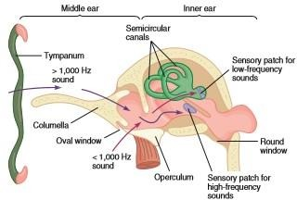

FIGURE 24.20 Ear of an Anuran (Posterior View). Red arrows show the pathway of low- frequency sounds, via the operculum. Dark-blue arrows show the pathway of high-frequency sounds, via the columella (stapes).

Lesson no 41
Excretion and Osmoregulation
The kidneys of amphibians lie on either side of the dorsal aorta on the dorsal wall of the body cavity. A duct leads to the cloaca, and a storage structure, the urinary bladder, is a ventral outgrowth of the cloaca. The nitrogenous waste product that amphibians excrete is either ammonia or urea. Amphibians that live in freshwater excrete ammonia. It is the immediate end product of protein metabolism; therefore, no energy is expended converting it into other products. The toxic effects of ammonia are avoided because it rapidly diffuses into the surrounding water. Amphibians that spend more time on land excrete urea that is produced from ammonia in the liver. Although urea is less toxic than ammonia, it still requires relatively large quantities of water for its excretion. Unlike ammonia, urea can be stored in the urinary bladder. Some amphibians excrete ammonia when in water and urea when on land. One of the biggest problems that amphibians face is
osmoregulation. In water, amphibians face the same osmoregulatory problems as freshwater ﬁshes. They must rid the body of excess water and conserve essential ions. Amphibian kidneys produce large quantities of hypotonic urine, and the skin and walls of the urinary bladder transport Na, Cl and other ions into the blood. On land, amphibians must conserve water. Adult amphibians do not replace water by intentional drinking, nor do they have the impermeable skin characteristic of other tetrapods or kidneys capable of producing a hypertonic urine. Instead, amphibians limit water loss by behavior that reduces exposure to desiccating conditions. Many terrestrial amphibians are nocturnal. During daylight hours, they retreat to areas of high humidity, such as under stones, or in logs, leaf mulch, or burrows. Water lost on nighttime foraging trips must be replaced by water uptake across the skin while in the retreat. Diurnal amphibians usually live in areas of high humidity and rehydrate themselves by entering the water. Many amphibians reduce evaporative water loss by reducing the amount of body surface exposed to air. They may curl their bodies and tails into tight coils and tuck their limbs close to their bodies (ﬁgure 19.15a). Individuals may form closely packed aggregations to reduce overall surface area. Some amphibians have protective coverings that reduce water loss. Hardened regions of skin are resistant to water loss and may be used to plug entrances to burrows or other retreat openings to maintain high humidity in the retreat. Other amphibians prevent water loss by forming cocoons that encase the body during long periods of dormancy. Cocoons are made from outer layers of the skin that detach and become parchmentlike. These cocoons open only at the nares or the mouth and, in experimental situations, reduce water loss 20 to 50% over noncocooned individuals (ﬁgure 19.15b). Paradoxically, the skin—the most important source of water loss—is also the most important structure for rehydration. When an amphibian ﬂattens its body on moist surfaces, the skin, especially in the ventral pelvic region, absorbs water. The skin’s permeability, vascularization, and epidermal sculpturing all promote water reabsorption. Minute channels increase surface area and spread water over surfaces not necessarily in direct contact with water. Amphibians can also temporarily store water. Water accumulated in the urinary bladder and lymph sacs can be selectively reabsorbed to replace evaporative water loss. Amphibians living in very dry environments can store volumes of water equivalent to 35% of their total body weight.

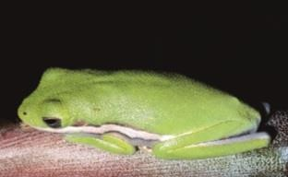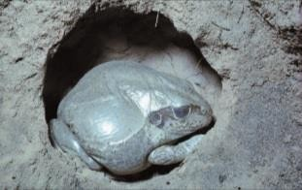

FIGURE 19.15 Water Conservation by Anurans. (a) Daytime sleeping posture of the green tree frog, Hyla cinerea. The closely tucked appendages reduce exposed surface area. (b) The Australian burrowing frog, Cyclorana alboguttatus, in its burrow and water-retaining skin.

Lesson no 42
REPRODUCTION, DEVELOPMENT, AND METAMORPHOSIS
Amphibians are dioecious, and ovaries and testes are located near the dorsal body wall. Fertilization is usually external, and because the developing eggs lack any resistant coverings, development is tied to moist habitats, usually water. A few anurans have terrestrial nests that are kept moist by being enveloped in foam or by being located near the water and subjected to ﬂooding. In a few species, larval stages are passed in the egg membranes, and the immatures hatch into an adultlike body. The main exceptions to external fertilization in amphibians are the salamanders. Only about 10% of all salamanders have external fertilization. All others produce spermatophores, and fertilization is internal. Eggs may be deposited in soil or water or retained in the oviduct during development. All caecilians have internal fertilization, and 75% have internal development. Amphibian development, which zoologists have studied extensively, usually includes larval stages called tadpoles. Amphibian tadpoles often differ from the adults in mode of respiration, form of locomotion, and diet. These differences reduce competition between adults and larvae. Interactions between internal (largely hormonal) controls and extrinsic factors determine the timing of
reproductive activities. In temperate regions, temperature seems to be the most important environmental factor that induces physiological changes associated with breeding, and breeding periods are seasonal, occurring in spring and summer. In tropical regions, amphibian breeding correlates with rainy seasons. Courtship behavior helps individuals locate breeding sites and identify potential mates. It also prepares individuals for reproduction and ensures that eggs are fertilized and deposited in locations that promote successful development. Salamanders rely primarily on olfactory and visual cues in courtship and mating, whereas male vocalizations and tactile cues are important for anurans. Many species congregate in one location during times of intense breeding activity. Male vocalizations are usually species speciﬁc and function in the initial attraction and contact between mates. After that, tactile cues become more important. The male grasps the female—his forelimbs around her waist—so that they are oriented in the same direction, and the male is dorsal to the female. This positioning is called amplexus and may last from 1 to 24 hours (ﬁgure 19.16). During amplexus, the male releases sperm as the female releases eggs. Little is known of caecilian breeding behavior. Males have an intromittent organ that is a modiﬁcation of the cloacal wall, and fertilization is internal.

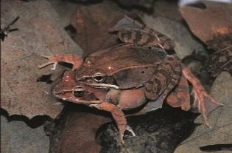
FIGURE 19.16 Amplexus. In frogs, eggs are released and fertilized when the male (smaller frog) mounts and grasps the female. This positioning is called amplexus.

Vocalization
Sound production is primarily a reproductive function of male anurans. Advertisement calls attract females to breeding areas and announce to other males that a given territory is occupied. Advertisement calls are species speciﬁc, and the repertoire of calls for any one species is limited. The calls may also help induce psychological and physiological readiness to breed. Females respond by making reciprocation calls to indicate receptiveness. Release calls inform a partner that a frog is incapable of reproducing. Unresponsive females give release calls if a male attempts amplexus, as do males that have been mistakenly identiﬁed as female by another male. Distress calls are not associated with reproduction; either sex produces these calls in response to pain or being seized by a predator. The calls may be loud enough to cause a predator to release the frog. The distress call of the South American jungle frog, Leptodactylus pentadactylus,is a loud scream similar to the call of a cat in distress. The sound-production apparatus of frogs consists of the larynx and its vocal cords. This laryngeal apparatus is well developed in males, who also possess a vocal sac. In the majority of frogs, vocal sacs develop as a diverticulum from the lining of the buccal cavity (ﬁgure 19.17). Air from the lungs is forced over the vocal cords and cartilages of the larynx, causing them to vibrate. Muscles control the tension of the vocal cords and regulate the frequency of the sound. Vocal sacs act as resonating structures and increase the volume of the sound. The use of sound to attract mates is especially useful in organisms that occupy widely dispersed habitats and must come together for breeding. Because many species of frogs often converge at the same pond for breeding, ﬁnding a mate of the proper species could be chaotic. Vocalizations help to reduce the chaos.
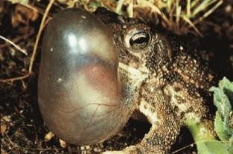

FIGURE 19.17 Anuran Vocalization. (a) Generalized vocal apparatus of an anuran. (b) Inﬂated vocal sac of the Great Plains toad, Bufo cognatus

Lesson no 43

Parental Care
Parental care increases the chances of any one egg developing, but it requires large energy expenditures on the part of the parent. The most common form of parental care in amphibians is attendance of the egg clutch by either parent. Maternal care occurs in species with internal fertilization (predominantly salamanders and caecilians), and paternal care may occur in species with external fertilization (predominantly anurans). It may involve aeration of aquatic eggs, cleaning and/or moistening of terrestrial eggs, protection of eggs from predators, or removal of dead and infected eggs. Eggs may be transported when development occurs on land. Females of the genus Pipa carry eggs on their backs. Two species of Rheobatrachus were discovered in Australia within the last 30 years. They have not been observed in the wild since the 1980s and are presumed extinct. Rheobatrachus females brooded tadpoles in their stomachs, and the young emerged from the females’ mouths (figure 19.18)! Unfortunately, we will never know whether the female swallowed fertilized eggs and all development occurred in her stomach or whether she swallowed tadpoles. During brooding, the female’s stomach expanded to ﬁll most of her body cavity, and the stomach stopped producing digestive secretions. Viviparity and ovoviviparity occur primarily in salamanders and caecilians.
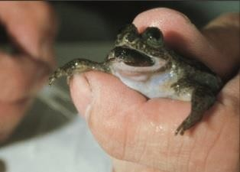

FIGURE 19.18 Parental Care of Young. Female Rheobatrachus with young emerging from her mouth. This Australian frog species has not been observed in the wild since the 1980s and is now presumed extinct.

Metamorphosis
Metamorphosis is a series of abrupt structural, physiological, and behavioral changes that transform a larva into an adult. A variety of environmental conditions, including crowding and food availability, inﬂuence the time required for metamorphosis. Most directly, however, metamorphosis is under the control of neurosecretions of the hypothalamus, hormones of the anterior lobe of the pituitary gland (the adenohypophysis), and the thyroid gland. Morphological changes associated with the metamorphosis of caecilians and salamanders are relatively minor. Reproductive structures develop, gills are lost, and a caudal ﬁn (when present) is lost. In the Anura, however, changes from the tadpole into the small frog are more dramatic (ﬁgure 19.19). Limbs and lungs develop, the tail is reabsorbed, the skin thickens, and marked changes in the head and digestive tract (associated with a new mode of nutrition) occur. The mechanics of metamorphosis explain paedomorphosis in amphibians. Some salamanders are paedomorphic because cells fail to respond to thyroid hormones, whereas others are paedomorphic because they fail to produce the hormones associated with metamorphosis. In some salamander families, paedomorphosis is the rule. In other families, the occurrence of paedomorphosis is variable and inﬂuenced by environmental conditions. that amphibians require. Mining, drilling, industrial and agricultural operations, and urban sprawl also destroy habitat. Amphibian populations are disappearing, however, from vast areas of the earth, often in regions where local damage has not occurred. Two additional culprits seem to be partly responsible for the decline of amphibian populations—acid

deposition and ultraviolet radiation (see chapter 6). Amphibian embryos are especially susceptible to changes in the pH of their watery environment. A pH of 5 or less will kill most embryos. In the northern hemisphere, it is estimated that environments are 100 times more acidic than they were before the Industrial Revolution. Ultraviolet radiation, especially in the 280 to 320 nm range (UV- B), also kills amphibian eggs and embryos. Pollutants that contribute to acid deposition and deplete the ozone shield of the earth may be partly responsible for the alarming reductions in amphibian populations. None of these explanations account for all problems with amphibian populations. Even in remote tropical regions, where none of these problems exist, amphibian populations are experiencing similar declines. The causes are unknown. It is imperative that the world’s governments and funding agencies make funds available to help scientists discover the causes and reverse this alarming trend.

